Rundown for the Volunteer Day at Tin Fu Tsai North Mountain Bike Trail
(12 Jan 2020)

8:45am | Shuttle bus at Tsuen Wan MTR Station (Please see the map attached)
9:30am | Gathering at the exit of Tin Fu Tsai North Mountain Bike Trail
9:30am to 9:45am | Briefing , Warm up Exercise  Pick up tools | Path maintenance and construction with stones
9:45am | Start trail maintenance work  (volunteers can be divided into 3-4 groups:  - Trail maintenance work | One leader for each team  (About 5-6 volunteers for each team)
12:00am | Lunch break ( BYOL), with fruits provided by AFCD
1:30pm | Trail works continue
3:30pm | Finish trail works and round up  Shuttle to go back to Tsuen Wan MTR
4:15 pm | End of volunteer day

The location map of the Pickup point (shuttle bus)

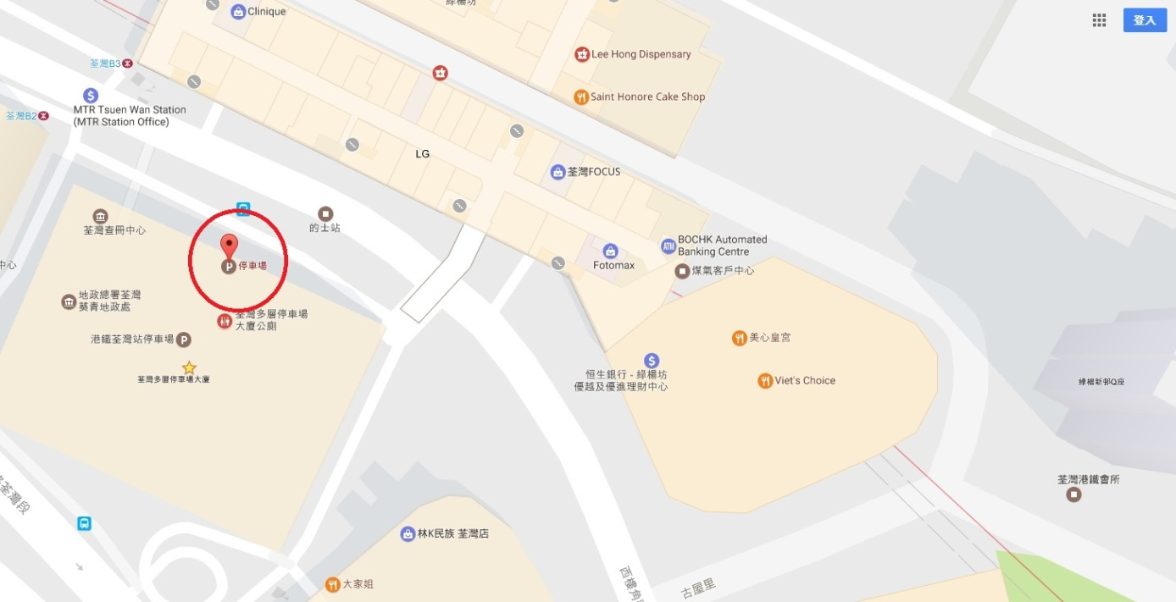

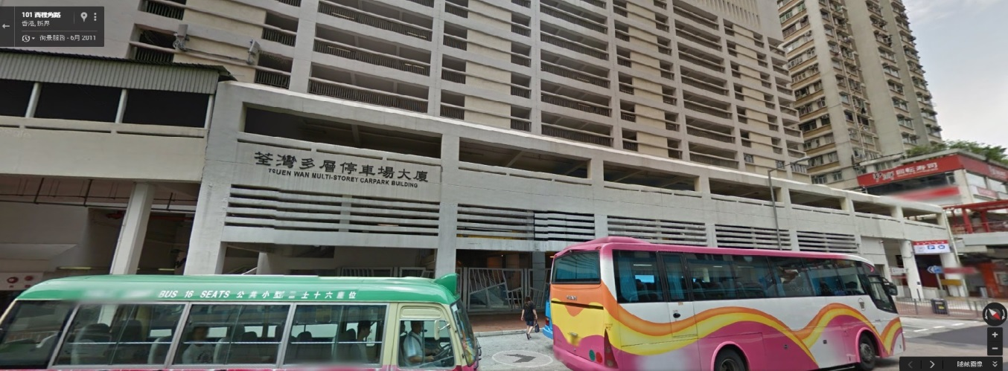

The location map of voluntary work (Tin Fu Tsai North Mountain Trail)
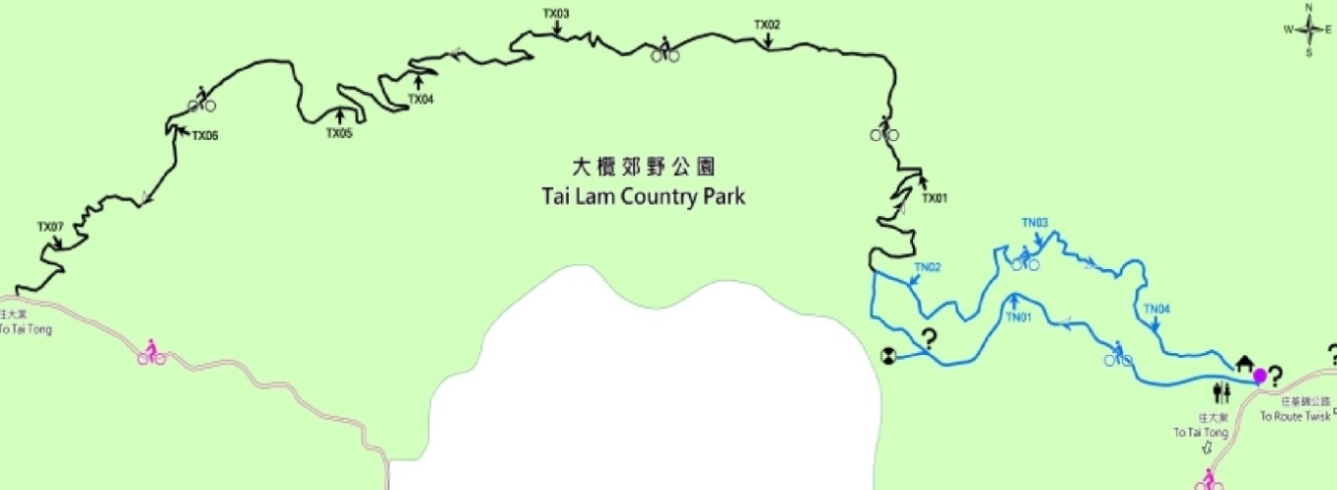
Work location
Briefing point

