 | The Government of the Hong Kong Special Administrative Region
Application Form for New Marine Fish Culture Licence |  |  |  |  |  |  |  |  |  | Application No.:  (For Department Use)
(In accordance with Section 8 of the Marine Fish Culture Ordinance (Cap. 353))
Application is made by: |  |  |  |  | An individual |  |  |  | An incorporated company
Name of Applicant: |  |  | Chinese Block Letter |  |  | English Block Letter
Hong Kong Identity Card number/Passport number/Hong Kong Business Registration Certificate number of applicant*:
Name of authorised person:  (If applicable) |  |  | Chinese Block Letter |  |  | English Block Letter
Hong Kong Identity Card number/Passport number of authorised person*:  (If applicable) |  |  |  |  |  | Capacity in the company#:
Correspondence address:
Telephone number: |  |  |  |  |  | Email address:
Is the applicant an existing holder of marine fish culture licence? |  |  |  | Yes |  | Licence number:
 |  |  |  |  |  | Fish Culture Zone:
 |  |  |  | No
Is the applicant a past/an existing trawl fisherman? |  |  | Yes No
Choice of Fish Culture Zone@: |  |  | First choice |  |  |  | Second choice
Required licence area (m²):
*I/This company solemnly and sincerely make this declaration that I/this company has read and understood the Notes to Applicant. All statements and information made in this application form and any other statements, information and documents provided in respect of this application are true and correct.

* Applicant/director/authorized person ’s signature |  | Company seal  (If applicable) |  |  |  |  |  | Date
[Note: Please put a tick ‘’in the appropriate box; *Delete as appropriate; # Only applicable to incorporated companies; @ The area and location of licensable area is for reference only, the actual licensable area and location will depend on the actual situation of individual fish culture zones.]
Notes on personal data
Purposes of Collection
- The personal data provided in this form will be used by Agriculture, Fisheries and Conservation Department for the following purposes:
- To consider and handle all matters in connection with the application made in this application form;
- To update the data record;
- To implement requirements of relevant provisions of the Marine Fish Culture Ordinance, Cap. 353; and
- To contact the applicant and authorised person.
- It is not obligatory for you to supply the personal data as required by this form. However, if you do not provide sufficient information, this Department may not be able to process your application.
Classes of Transferees
- The personal data you provided by means of this form may be disclosed to other Government departments, bureaux and officers who are responsible to handle and implement matters relating to the Marine Fish Culture Ordinance (Cap. 353).
Access to Personal Data
- You are entitled to request access and correction of your personal data in accordance with sections 18 and 22 and principle 6 of Schedule 1 of the Personal Data (Privacy) Ordinance. Your right of access includes the right to obtain a copy of your personal data as provided in this form.
Enquires
- For any request for the access to or correction of personal data, please contact our staff at 2150 7108 or send your request by post to the Fisheries Enforcement and Special Projects Division, Agriculture, Fisheries and Conservation Department, 8/F Cheung Sha Wan Government Offices, 303 Cheung Sha Wan Road, Kowloon.

Notes to Applicant
- Applications must be submitted on or before 2 March 2020. Please submit required documents by post, in person, or by an authorised person to Licensing and Enforcement Section, Fisheries Enforcement and Special Project Division, Agriculture, Fisheries and Conservation Department, 8/F Cheung Sha Wan Government Offices, 303 Cheung Sha Wan Road, Kowloon or email to fish_lic_enf@afcd.gov.hk.
- Applicants are required to submit the following documents:
- A completed application form signed by the applicant – If the applicant is an incorporated company, the application form shall be signed by the director or the authorised person of the company and stamped with the company chop;
- Photocopies of the applicant’s identity documents – For individuals: Hong Kong Identity Card or Passport; for incoporated companies: Hong Kong Business Registration Certificate, a certified copy of the Certificate of Incorporation of the company and a certified copy of its latest Annual Return;
- A photocopy of the Hong Kong Identity Card or Passport of the authorised person;
- An authorisation letter signed by the applicant – If an incorporated company authorises a person otherwise than a director to handle and sign the application form, the company shall provide a certified copy of the board resolution showing the authorisation made. Such board resolution shall be signed by director(s) of the company and stamped with the company chop;
- A photocopy of the proof of address of the applicant – For example: a bill or a bank statement, the issue date of which is not more than 3 months from the date of application; and
- A business plan – The applicant is required to provide a business plan in support of the application. The business plan shall include information listed in Appendix I and show clearly how the proposed mariculture business could achieve sustainable development of mariculture. The Agriculture, Fisheries and Conservation Department (“AFCD”) will evaluate the applications according to the “Marking Scheme for Evaluating Applications for New Licences” set out in Appendix II. Successful applicants shall conduct mariculture in accordance with the submitted business plan. AFCD will not consider applications conducting recreational fishing on fish rafts and/or seafood trade activities.
- AFCD will not consider applications from the following person: 1) whose business has been affected by marine works projects in Hong Kong waters and has been granted ex-gratia allowance to cease his business for good at the Fish Culture Zone (“FCZ”) in respect of which the application has been made; and undertook that he will not apply to the Director of Agriculture, Fisheries and Conservation (“DAFC”) for new marine fish culture licence (“the licence”) at the FCZ in respect of which the application has been made; 2) whose marine fish culture licence was cancelled within five years due to contravention of the Marine Fish Culture Ordinance, Marine Fish Culture Regulation and/or the conditions of the licence. If the company director or shareholder of the incorporated company are the abovenamed persons, the company application will not be considered.
- AFCD will rank the applicants’ business plans, mariculture representatives will be invited to give comments on the business plans. New licences will be issued to applicants whose passing business plan scores the highest in their respective FCZs.
- The details of the licensable area in the respective FCZs are provided below, please refer to Figure on the location.
Fish Culture Zone | Details of Licensable Area
Cheung Sha Wan | Licensable area available in units of 1,000 sq m for application
O Pui Tong
Sham Wan
- AFCD may request applicant to provide additional information for processing their application. Failure to provide the additional information may result in the application being rejected by AFCD.
- Each successful applicant will be granted a licence. The licence is valid for one year according to the Marine Fish Culture Regulation. Application for renewal of licence shall be made not later than one month before the expiry of the licence.
- A “5-year operation period” shall apply to the new licence. The new licensee shall, six months prior to the expiry of the 5-year operation period, apply to continue his business according to the original business plan or a new business plan, failing to comply will result in non-renewal of licence after the 5-year operation period.
- DAFC may impose any conditions on the new licences to ensure that the operation of the farm will be consistent with the intended purpose. Failing to comply with the licensing conditions may result in cancellation of the licence.
- Applicants must not offer any advantages to government officials.

Figure I
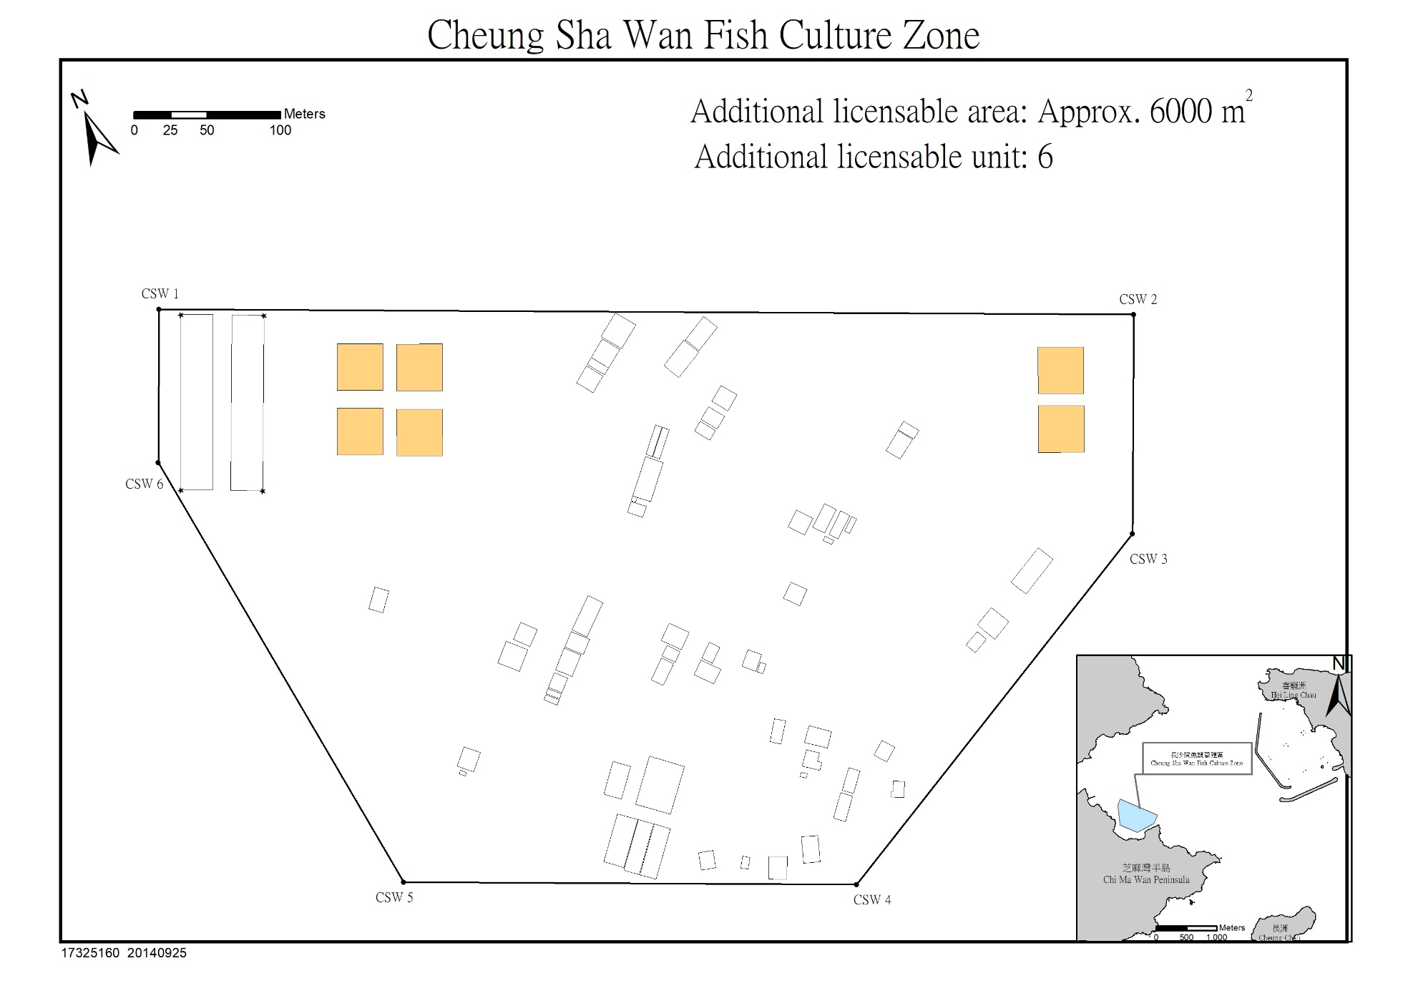
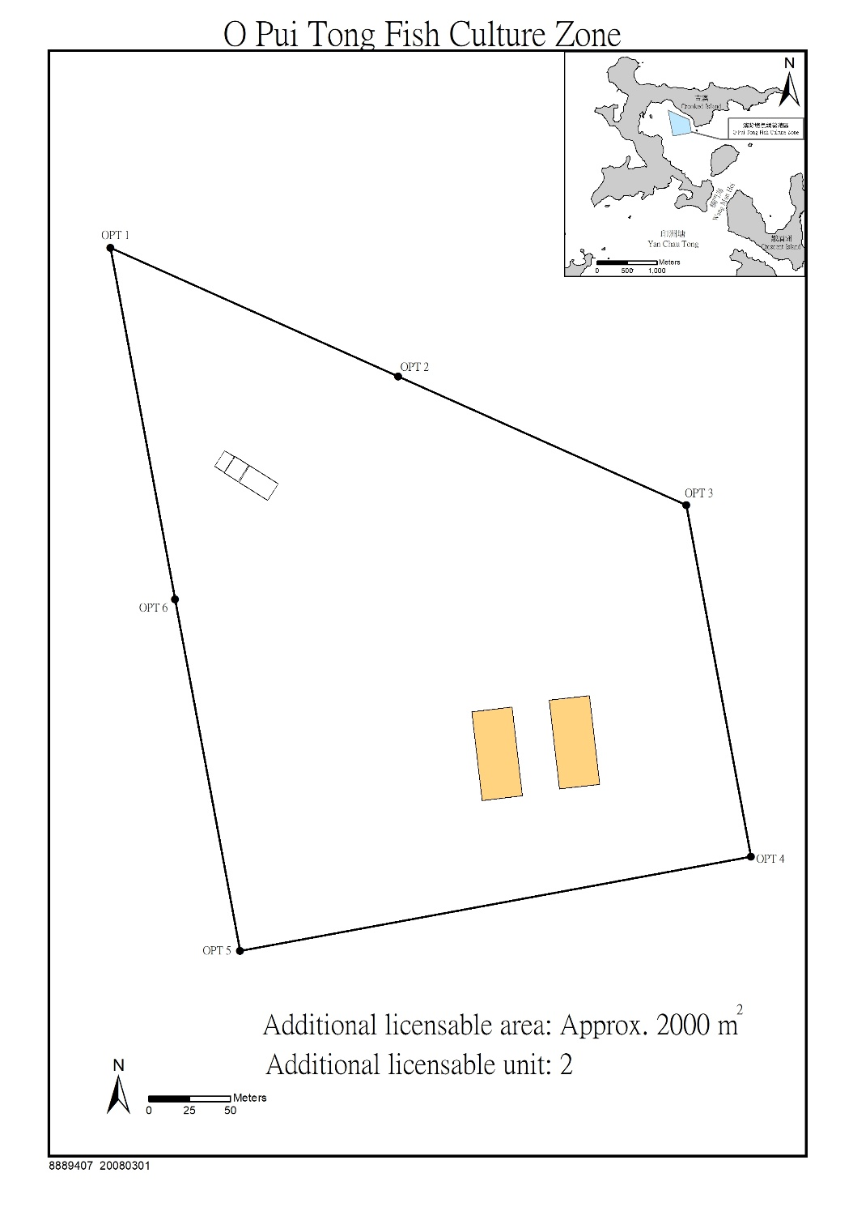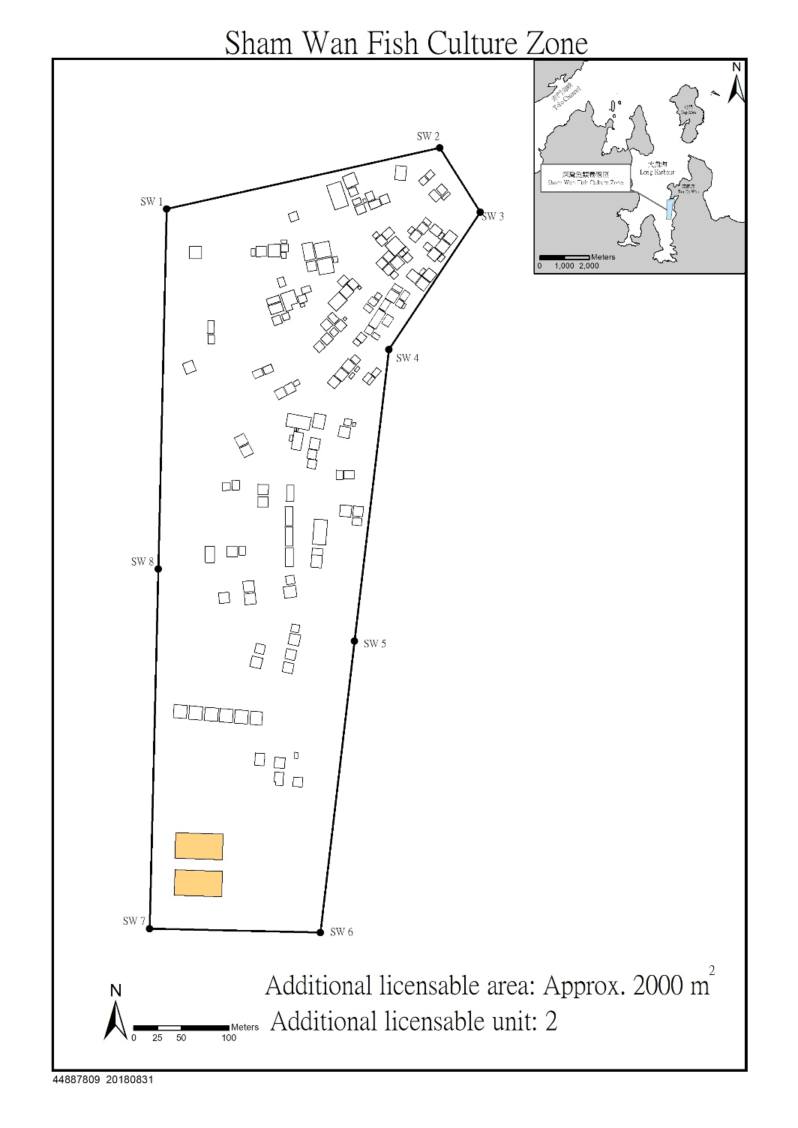
Appendix I
Business Plan
The business plan submitted by the applicant should include:

  - Sustainable development of aquaculture
    - cultured species
    - target production
    - market demand and anticipated profit of cultured species
    - biological factors of cultured species such as fry source, growth rate, disease resilience etc.
  - Production feasibility
    - types, structure, materials, design and layout of the fish culture farm
    - schedule of implementation, including culture period, feeding rate and weight, harvest tactics
    - strategies to reduce loss due to oxygen depletion, winter kill, parasites, disease, predators and cannibalism etc.
    - strategies to improve quality of fish products and to control food safety
    - fish products sales strategies
  - Environmental sustainability
    - the use of feed and feed additives
    - monitoring of water quality and environment in vicinity
    - hygiene and quarantine measures, the use of drugs and antimicrobial resistance monitoring
  - Management capability
    - roles, tasks and involvement of production team
    - equipment, technology and management for daily operation
    - fish farm operation log
  - Others
    - qualifications of production team and other documents to support the experience in fish culture
    - financial budget
    - existing business operation (applicable to marine fish culture licensee)
Appendix II
Marking Scheme for Evaluating Applications for New Licences

Assessment Criteria | Assessment Item | Basis of Assessment
Sustainable development of aquaculture  (Maximum score: 20) | Scale of production | A business plan scores higher if the proposed target production is reasonable; if the plan can describe how a full culture cycle will be completed, how target production can be achieved within the 5-year operation period and the stocking density at different operation stages (e.g. initial stocking density).
 | Market of cultured species | Local, new species scores higher.
 | Biological factors of cultured species | Fry from reputable suppliers or with health certificates from origin scores higher.
Production feasibility  (Maximum score: 30) | Types, structure and materials of fish culture farm | An HDPE fish farm with design against wave attack, effective utilisation of culture area and reasonable layout for culture scores higher.
 | Schedule of implementation | A business plan depicting the culture method, including technical aspects such as stocking time, stocking weight/number, feed rate and weight, and harvest strategy scores higher.
 | Measures in preventing production loss problems | A business plan demonstrating proactive management strategies in minimising risk of production loss due to oxygen depletion, winter kill, parasites, disease, predators, cannibalism etc. scores higher.
 | Food safety strategies | A business plan implementing a biosecurity plan scores higher.
 | Fish product sales strategies | A business plan providing proactive, innovative and diverse strategies for sales of fish products scores higher.
Environmental sustainability  (Maximum score: 25) | Use of feed and feed additives | A business plan using dry pellets wherever possible and with reduced use of trash fish scores higher.
 | Monitoring of water quality and environment in vicinity | A business plan depicting operation management and monitoring measures to maintain a good mariculture environment scores higher.
 | Health quarantine measures, use of drugs and monitoring against antimicrobial resistance | A business plan implementing good aquaculture practices and maintain proper record and storage of antibiotics using the “antibiotics storage and usage log” scores higher.
Technical and management capability  (Maximum score: 25) | Experience in mariculture* | Operator with ample working experience in aquaculture; adequate academic or technical capabilities in aquaculture production scores higher.
 | Role and duties of production team | A business plan hiring full time staff with experience in aquaculture and specifying roles and responsibilities of members of the production team scores higher.
 | Equipment, technology and management for daily operation | A business plan adopting new technologies and equipment which enables environmentally friendly, efficient and economic aquaculture production and demonstrating proactive management strategies in managing culture operation record scores higher.
 | Past violation records | Applicant without violations on the Marine Fish Culture Ordinance, Marine Fish Culture Regulation and/or the conditions of the licence in the past five year scores higher.
Remarks: Wait-listed applicants for marine fish culture licence or existing/past trawl fishermen will be awarded an additional 10 points.
*Applicant with no experience in mariculture but has completed mariculture training course organized by AFCD will be considered having related mariculture experience.

The applicant’s business plan must score at least 50% in any assessment criterion to pass the assessment. Only applications with business plans passing the assessment will be considered.

